Lesson 8 Demo 1
Docker Community Edition Installation
Objective: Install Docker Community Edition on Ubuntu

Tools required: Docker

Pre-requisites: Ubuntu Configuration

Note: Docker is pre-installed in your machine. In case it does not work on your machine or it is unavailable you can follow this demo to install it on your machine.

Steps to be followed:
- Install Docker CE from Docker Repository
- Verify the correctly installed Docker Engine

Step 1: Install the Docker CE from Docker Repository
1.1 Use the following command to update the apt package:
sudo apt-get update
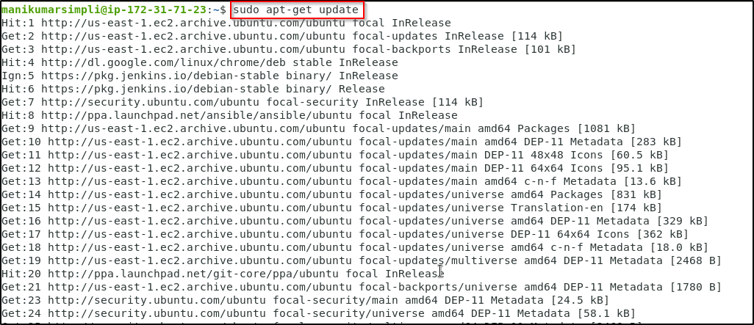
1.2 Use the following command to install packages to allow the apt to use a repository over HTTPS
sudo apt-get install \

apt-transport-https \
ca-certificates \
curl \
gnupg \
lsb-release
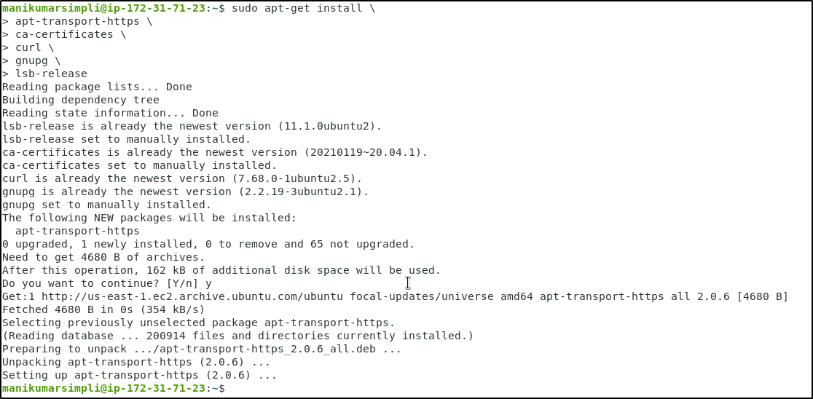
  - Use the following curl command to add Docker’s official GPG key:

curl -fsSL https://download.docker.com/linux/ubuntu/gpg | sudo gpg --dearmor -o /usr/share/keyrings/docker-archive-keyring.gpg
1.4 Use the following command to set up a stable repository:
echo \
"deb [arch=amd64 signed-by=/usr/share/keyrings/docker-archive-keyring.gpg] https://download.docker.com/linux/ubuntu \
$(lsb_release -cs) stable" | sudo tee /etc/apt/sources.list.d/docker.list > /dev/null

1.5 Use the following commands to install the latest version of Docker CE and check the version.

sudo apt update
sudo apt-get install docker-ce
docker --version

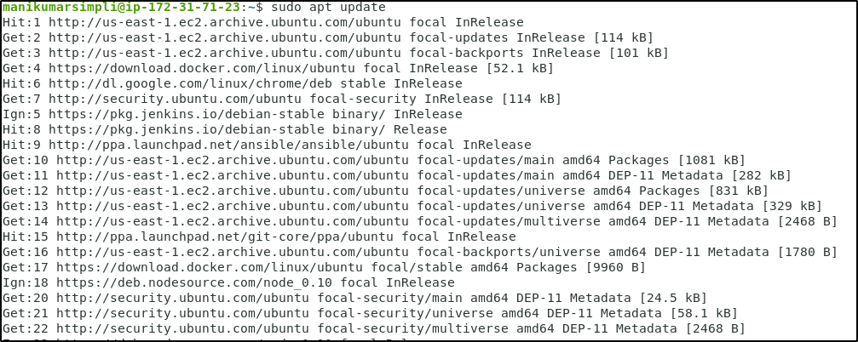
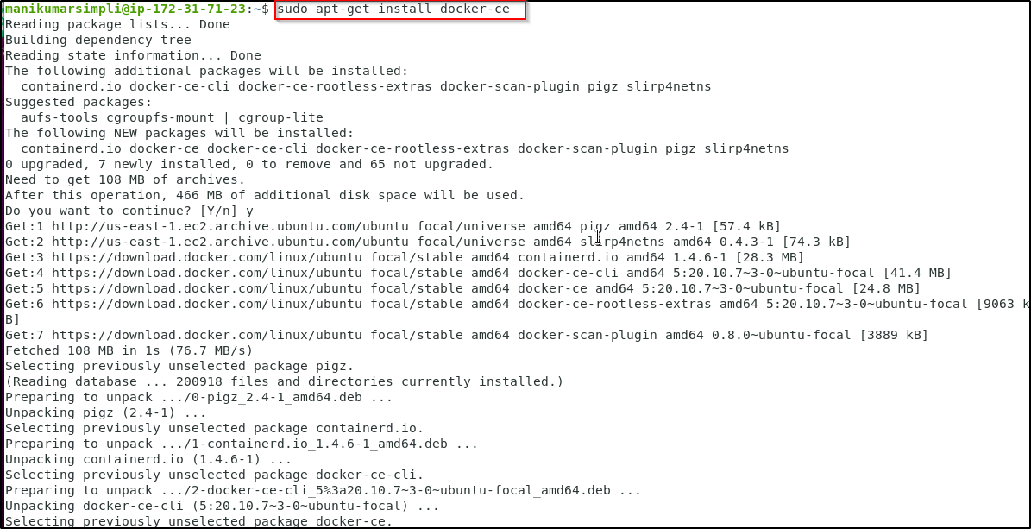

Step 2: Verify the correctly installed Docker engine
2.1 Use the following command to verify the Docker engine:
sudo docker run hello-world

